PowerShell Project

Overview
Five chapters covering core PowerShell skills: parsing and decrypting XML, connecting to and querying SQL Server, automating a browser with Selenium, writing a Desired State Configuration, and combining the results into a single report.

Chapter 1 — The Lost XML Scroll
Parse AncientScroll.xml, decrypt its Caesar-cipher-encoded content, and produce a decryption report.

Step 1.1 — Create the Project Folder and XML Source
Create a project folder and an AncientScroll.xml file containing the encrypted content, author, and date.
mkdir PowerShell-Capstone\Chapter1-XML
cd PowerShell-Capstone\Chapter1-XML

Step 1.2 — Write and Run the Decryption Script
Create chapter1.ps1. Load the XML, then shift each letter back by one position (reverse Caesar cipher) to decrypt the message.
$xmlPath = ".\AncientScroll.xml"
if (Test-Path $xmlPath) {
$xml = [xml](Get-Content -Path $xmlPath)
$encryptedText = $xml.SelectSingleNode('//Content').InnerText
$decryptedText = ""
foreach ($char in $encryptedText.ToCharArray()) {
if ($char -eq " ") {
$decryptedText += " "
} elseif ($char -ge 65 -and $char -le 90) {
$decryptedText += [char]((((($char - 65) - 1) % 26) + 26) % 26 + 65)
} elseif ($char -ge 97 -and $char -le 122) {
$decryptedText += [char]((((($char - 97) - 1) % 26) + 26) % 26 + 97)
} else {
$decryptedText += $char
}
}
Write-Host "Decrypted Text:"
Write-Host $decryptedText
} else {
Write-Host "The XML file '$xmlPath' does not exist."
}
Expected console output: Decrypted Text: The purpose of learning is growth, and our minds, unlike our bodies, can continue growing as we continue to live.
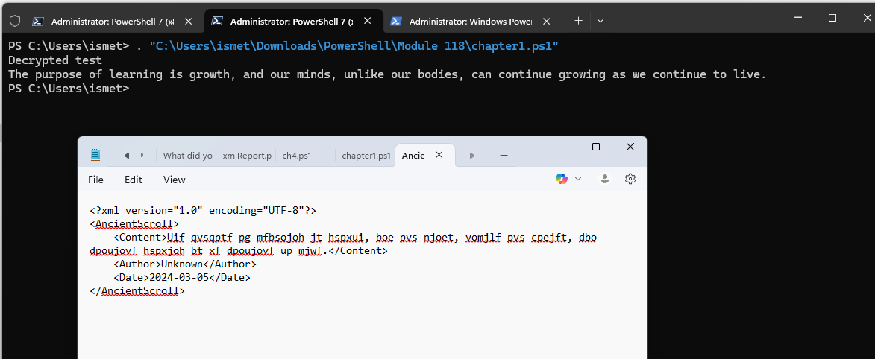
chapter1.ps1 run successfully, printing the decrypted message from AncientScroll.xml.

Step 1.3 — Generate the Decryption Report
Write the decrypted output, author, and date to a text report file (e.g. DecryptionReport.txt) for the discovered knowledge.
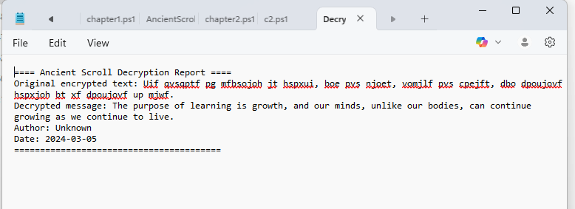
Final decryption report showing the original encrypted text, decrypted message, author, and date.

Chapter 2 — The Database Quest
Connect to a local SQL Server instance with PowerShell, create a table, insert sample data, and retrieve it.

Step 2.1 — Install SQL Server (Developer Edition)
Install SQL Server 2022 Developer Edition locally and confirm a successful installation before connecting from PowerShell.
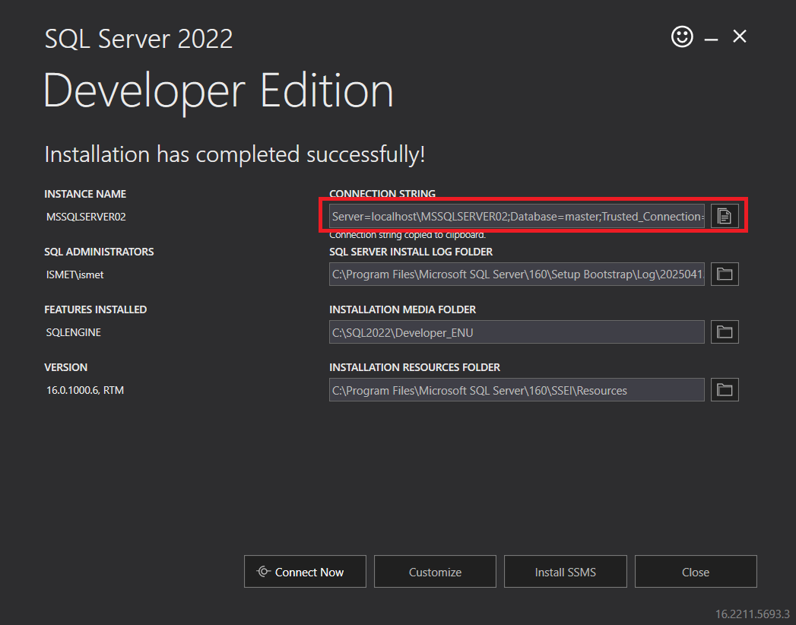
SQL Server 2022 Developer Edition installer confirming a successful install, instance name, and connection string.

Step 2.2 — Write and Run the Database Script
Create chapter2.ps1. Connect with Windows authentication, create a TreasureTable if it doesn't exist, insert sample records, then query and display them.
$connectionString = "Server=localhost;Database=master;Trusted_Connection=True;"
$connection = New-Object System.Data.SqlClient.SqlConnection
$connection.ConnectionString = $connectionString
$createTableQuery = @"
IF NOT EXISTS (SELECT * FROM sys.tables WHERE name = 'TreasureTable')
BEGIN
CREATE TABLE TreasureTable (
Id INT IDENTITY(1,1) PRIMARY KEY,
Name NVARCHAR(100) NOT NULL,
Value DECIMAL(10, 2) NOT NULL
)
END
ELSE
BEGIN
DROP TABLE TreasureTable
END
"@
try {
$connection.Open()
$command = $connection.CreateCommand()
$command.CommandText = $createTableQuery
$command.ExecuteNonQuery()
# Insert sample records (trimmed here — see chapter2.ps1 for the full list)
$command.CommandText = $insertDataQuery
$rowsInserted = $command.ExecuteNonQuery()
Write-Host "Inserted $rowsInserted sample records" -ForegroundColor Green
$command.CommandText = "SELECT * FROM TreasureTable"
$adapter = New-Object System.Data.SqlClient.SqlDataAdapter $command
$dataset = New-Object System.Data.DataSet
$adapter.Fill($dataset) | Out-Null
$dataset.Tables[0] | Format-Table -AutoSize
} catch {
Write-Host "Error: $_" -ForegroundColor Red
} finally {
if ($connection.State -eq 'Open') { $connection.Close() }
}
Expected console output: Inserted 51 sample records, followed by a formatted table of Id, Name, and Value columns.
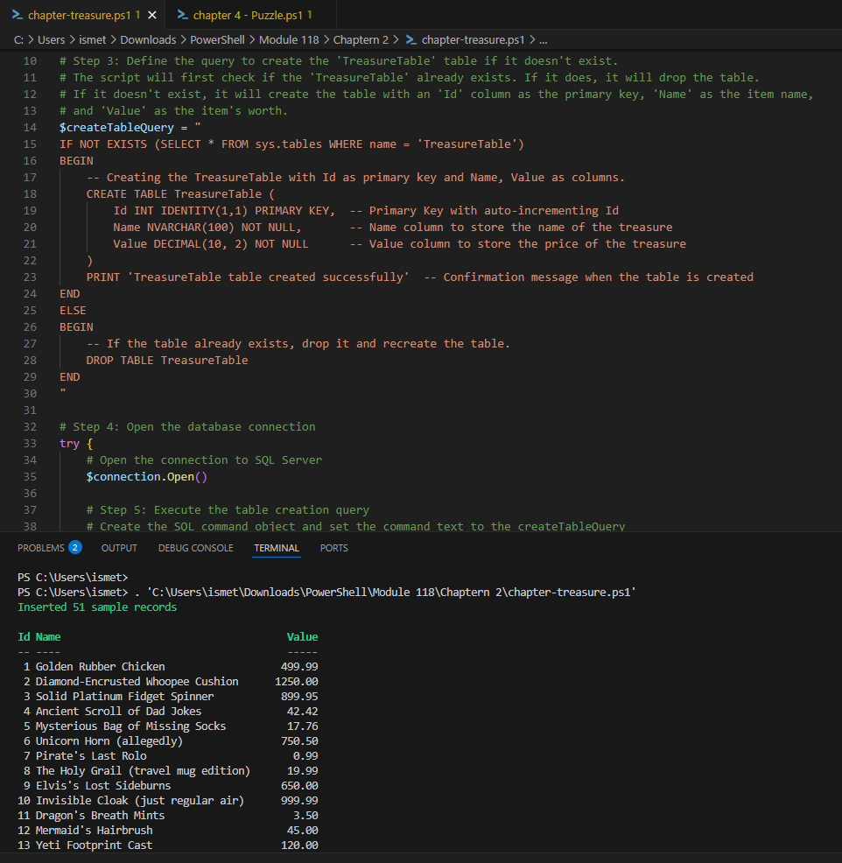
chapter2.ps1 run successfully — 51 sample records inserted and displayed from TreasureTable.

Chapter 3 — The Web Automation Odyssey
Use PowerShell with Selenium to automate a browser login/logout flow against a public practice site.

Step 3.1 — Review the Target Login Page
Confirm the practice login page and the credentials it expects before automating against it.
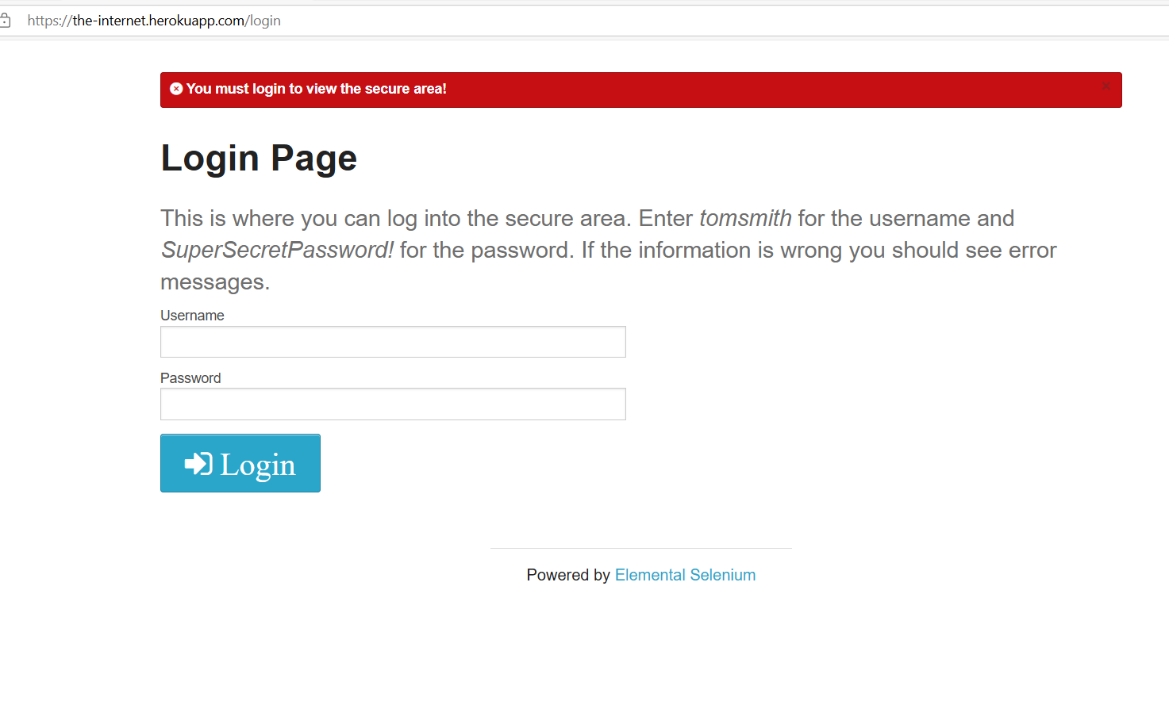
the-internet.herokuapp.com/login — the public practice site used for this automation.

Step 3.2 — Write and Run the Selenium Automation Script
Create WebAutomation.ps1. Launch ChromeDriver, navigate to the login page, fill in the credentials, submit, confirm success, then log out.
Import-Module Selenium
$chromeOptions = New-Object OpenQA.Selenium.Chrome.ChromeOptions
$chromeOptions.AddArgument("--headless")
$chromeOptions.AddArgument("--disable-gpu")
$driverDir = "C:\Selenium"
$driverExe = "chromedriver.exe"
$service = [OpenQA.Selenium.Chrome.ChromeDriverService]::CreateDefaultService($driverDir, $driverExe)
try {
$Driver = New-Object OpenQA.Selenium.Chrome.ChromeDriver($service, $chromeOptions)
$url = "https://the-internet.herokuapp.com/login"
$username = "tomsmith"
$password = "SuperSecretPassword!"
$Driver.Navigate().GoToUrl($url)
Start-Sleep -Seconds 3
Write-Host "Successfully navigated to: $($Driver.Title)"
$Driver.FindElementById("username").SendKeys($username)
$Driver.FindElementById("password").SendKeys($password)
$Driver.FindElementByClassName("radius").Click()
Start-Sleep -Seconds 3
$flashMessage = $Driver.FindElementById("flash").Text
Write-Host "Login result: $flashMessage"
if ($Driver.Url -like "*secure") {
Write-Host "Login successful! Now on secure page."
$Driver.FindElementByClassName("button").Click()
Start-Sleep -Seconds 3
Write-Host "Current URL after logout: $($Driver.Url)"
}
} finally {
if ($Driver) { $Driver.Quit() }
}
Expected console output: ChromeDriver starts, navigates successfully, logs in, confirms "You logged into a secure area!", logs out, and closes the browser cleanly.
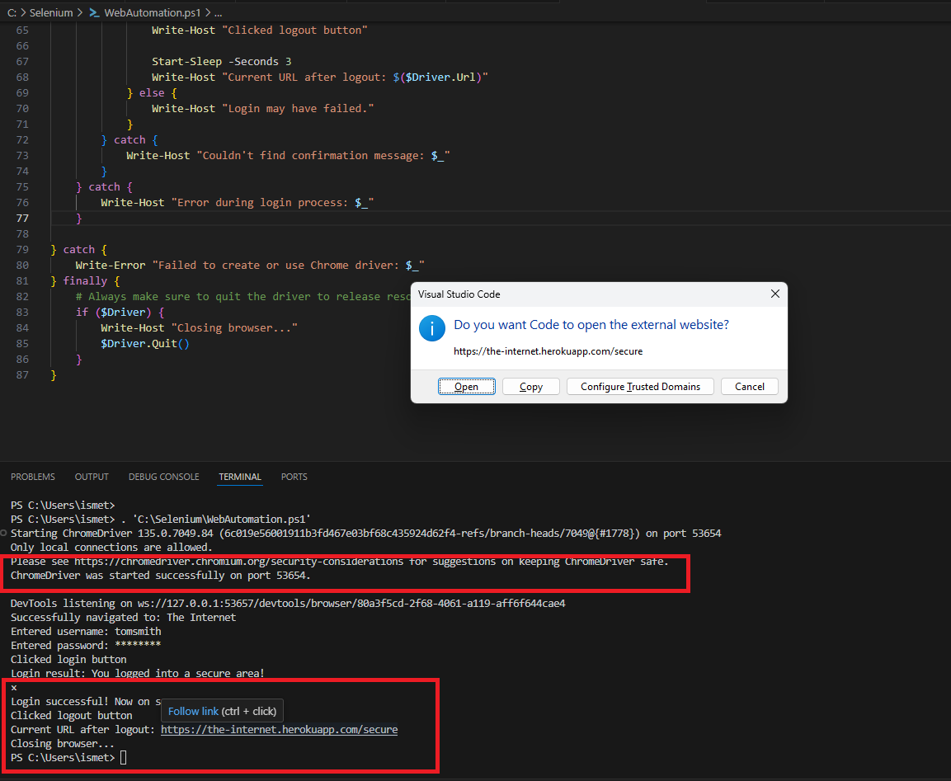
WebAutomation.ps1 run end-to-end — ChromeDriver started, login succeeded, logout completed, browser closed.

Step 3.3 — Confirm the Secure Page Visually
Confirm the browser actually reached the secure, logged-in page (this matches what the script's flash message reported).
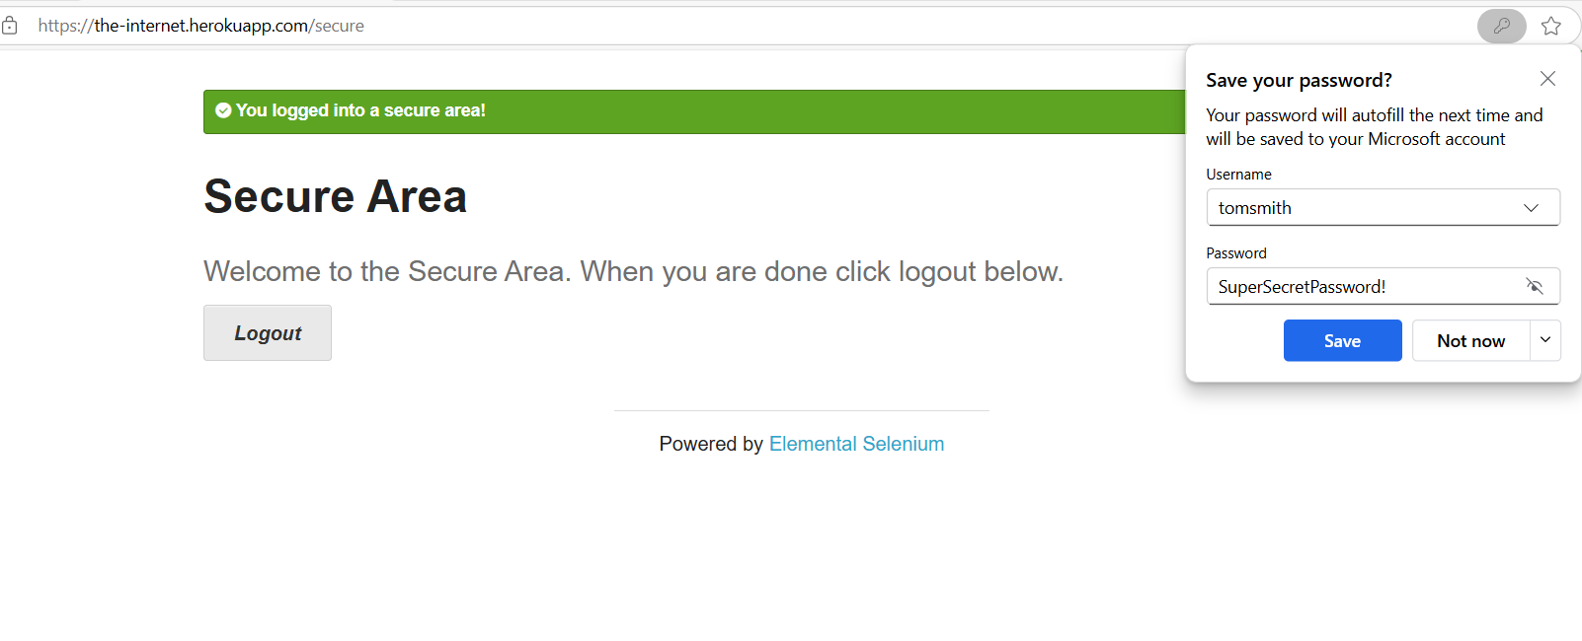
Browser showing "You logged into a secure area!" after the automated login.

Chapter 4 — The Desired State Conundrum
Write a Desired State Configuration (DSC) to enforce a web server role, directory, firewall rule, and service state, and attempt to apply it.

Step 4.1 — Write the DSC Configuration
Create KingdomServers.ps1 defining the desired state: Web-Server feature present, a content directory present, an inbound firewall rule, and the W3SVC service running.
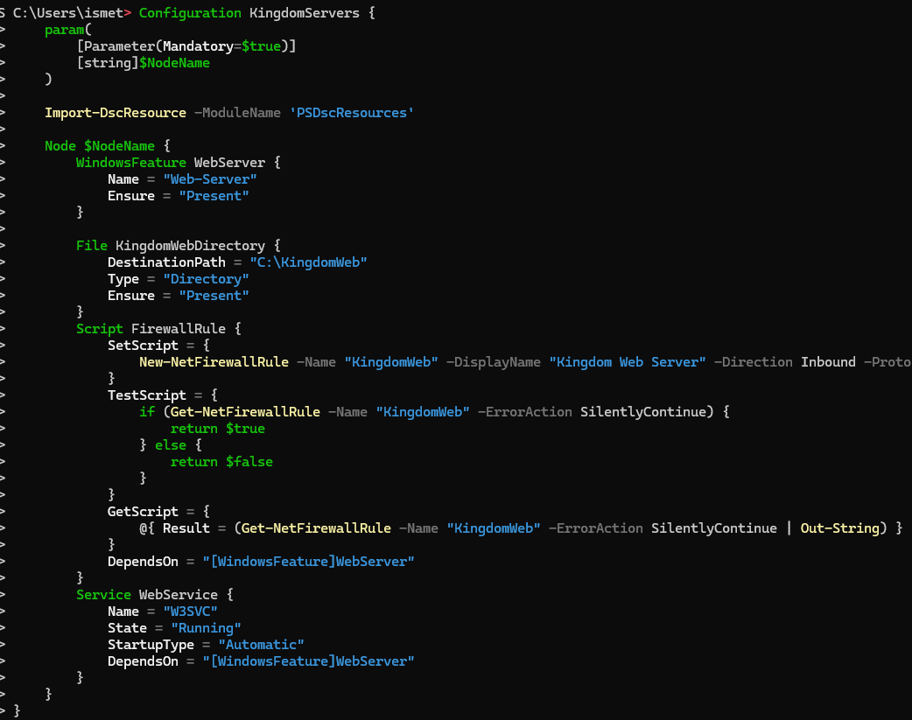
KingdomServers DSC configuration defining WindowsFeature, File, Script (firewall rule), and Service resources.

Step 4.2 — Compile and Apply the Configuration
Run the configuration to generate the .mof file, then attempt Start-DscConfiguration to apply it.
KingdomServers -NodeName "KingdomServer01" -OutputPath $configPath
Start-DscConfiguration -Path $configPath -Wait -Verbose -Force
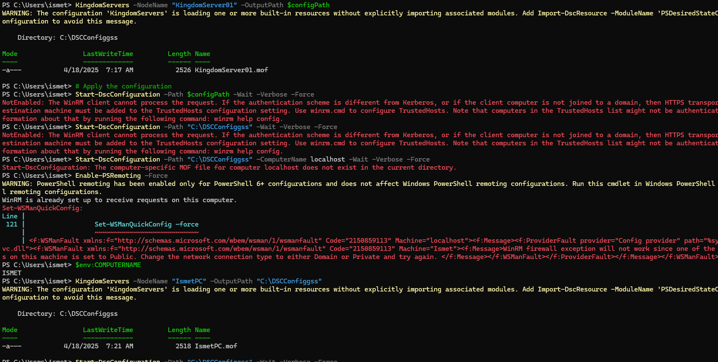
Configuration compiled to a .mof file successfully, but Start-DscConfiguration failed with a WinRM/TrustedHosts authentication error.

Step 4.3 — Troubleshoot Environment Limitations
Attempted Enable-PSRemoting, Get-WindowsOptionalFeature, and Install-WindowsFeature to work around the failure.
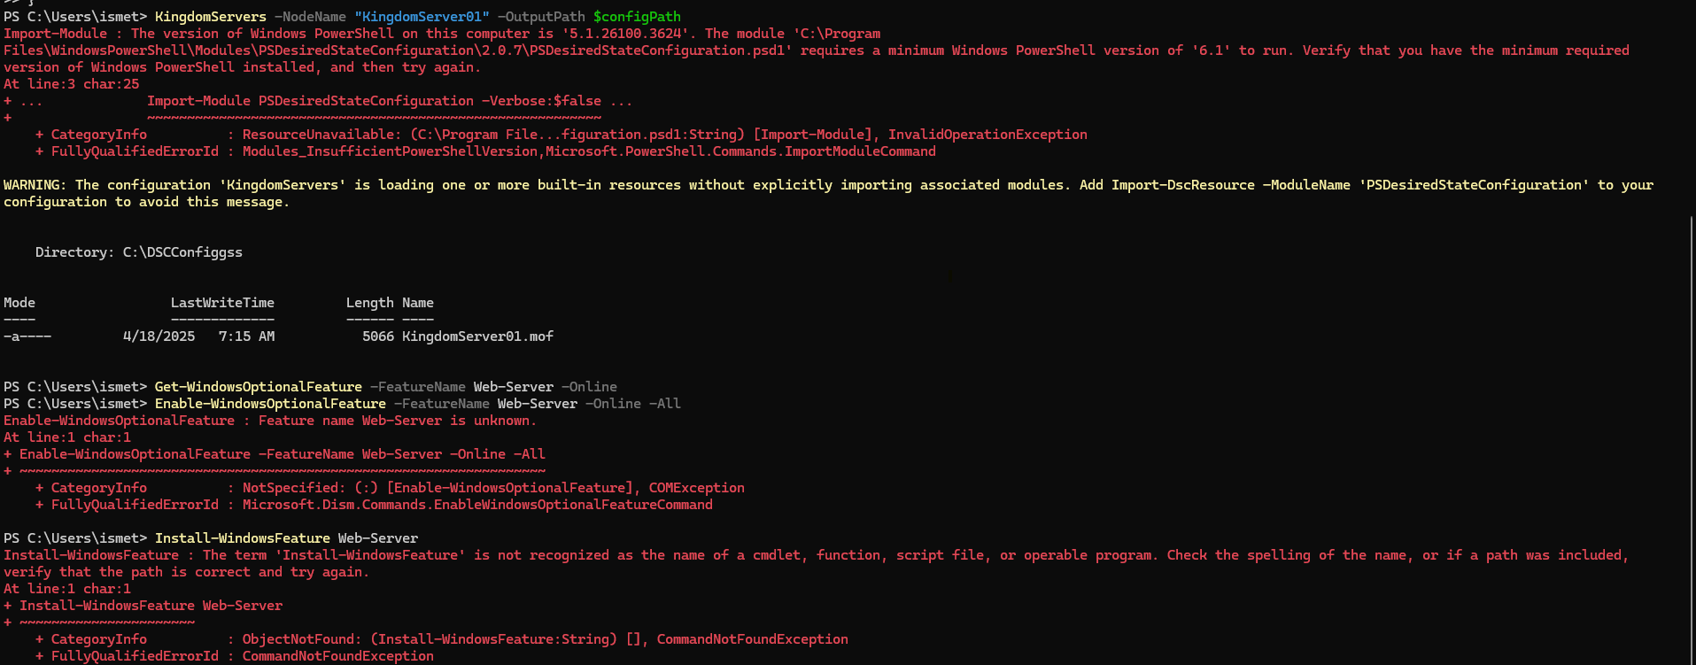
Troubleshooting attempts: PSDesiredStateConfiguration module version mismatch, Web-Server feature unrecognized, and Install-WindowsFeature unavailable on this OS edition.

Step 4.4 — Document the Outcome Honestly
Note: This chapter was not able to complete successfully: Install-WindowsFeature and the Web-Server optional feature are Windows Server-only capabilities, and this lab was run on a client edition of Windows. The configuration itself compiled correctly and is technically valid — applying it requires a genuine Windows Server target (or a Server-class VM) rather than a workaround on a client OS. This is documented here as-is rather than hidden, since it accurately reflects what was attempted and why it didn't fully succeed.

Chapter 5 — The Power of Unity
Integrate the XML decryption, database query, and web automation results into a single combined report.

Step 5.1 — Build the Convergence Script
Create Convergence.ps1 that calls into the logic from Chapters 1–3, collects each result, and writes a single combined summary report (e.g. KingdomReport.txt) covering the decrypted scroll message, the treasure table record count, and the web automation login/logout result.

Step 5.2 — Run and Verify the Combined Report
Run Convergence.ps1 and confirm the final report includes results from all three earlier chapters.

